**Working of angular app:**

1. User signs in to his/her account by using login service



2. User can register an account if he/she doesn’t have one

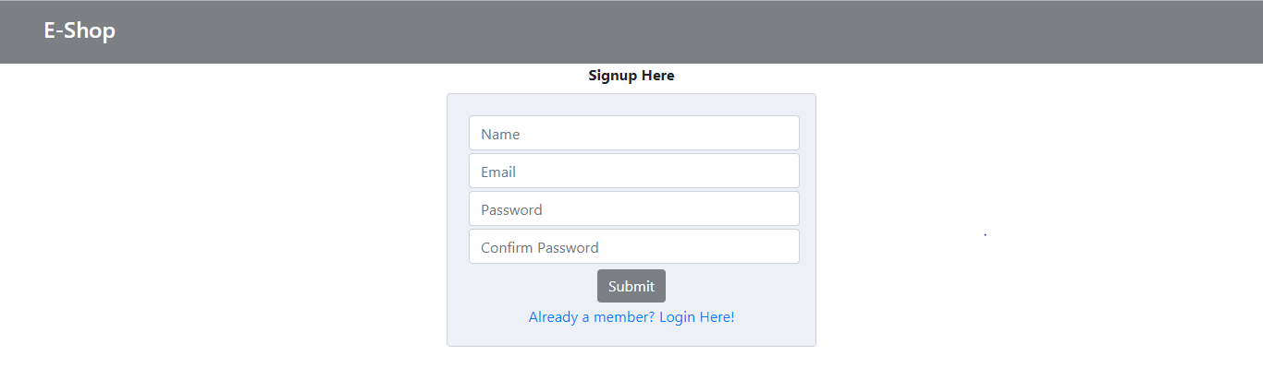

3. User chooses the product by clicking on buy now and product gets added to cart

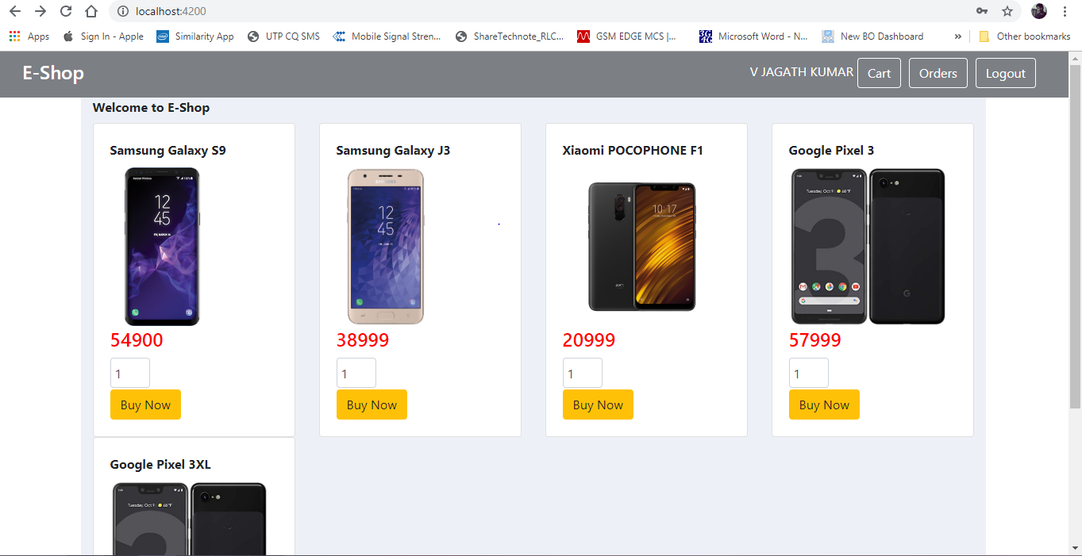

4. The can modify the cart or user can choose payment option to proceed to place the order from the cart and the app redirects to payment page

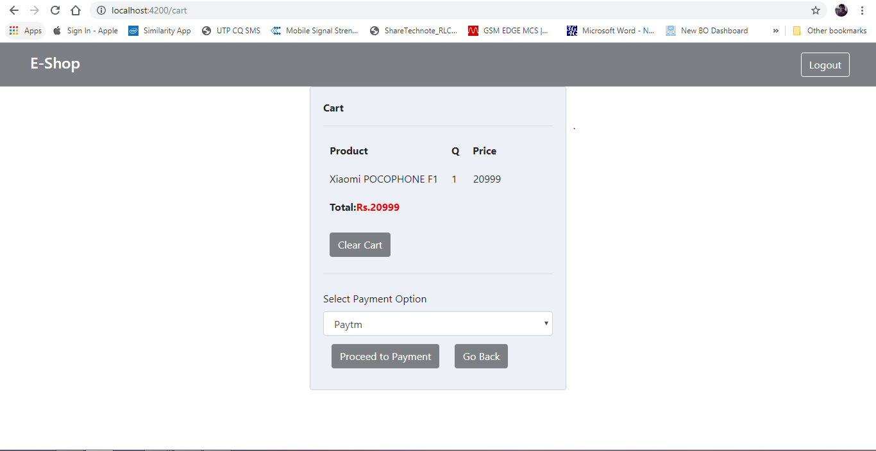

5. In Payment page user provides the chosen payment method details to pay.

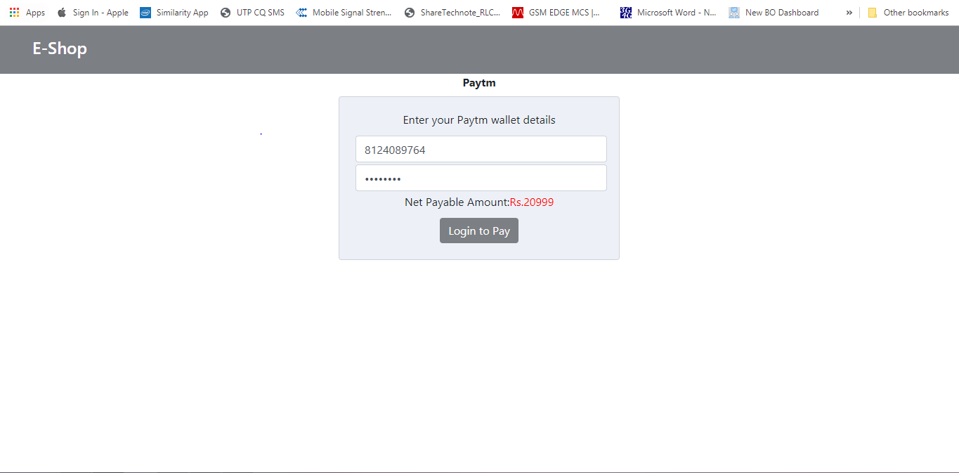

6. Once the Payment is successful order is placed and user gets notified about order details.

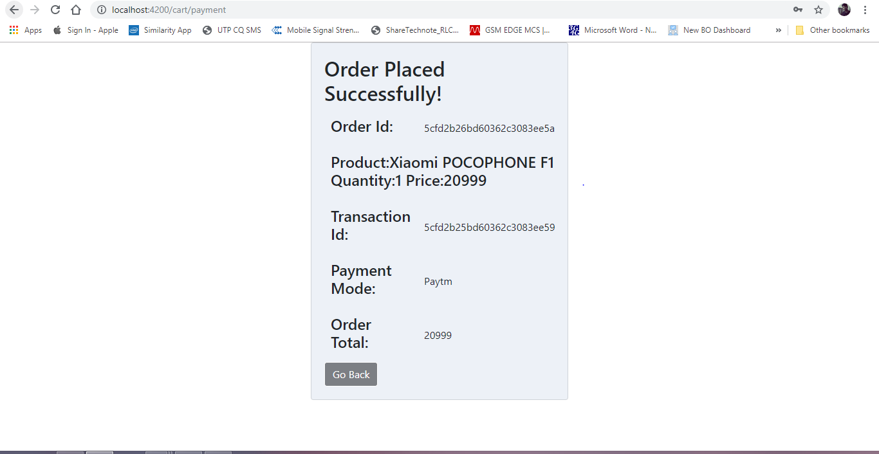

7.User can view the orders that he/she has placed.

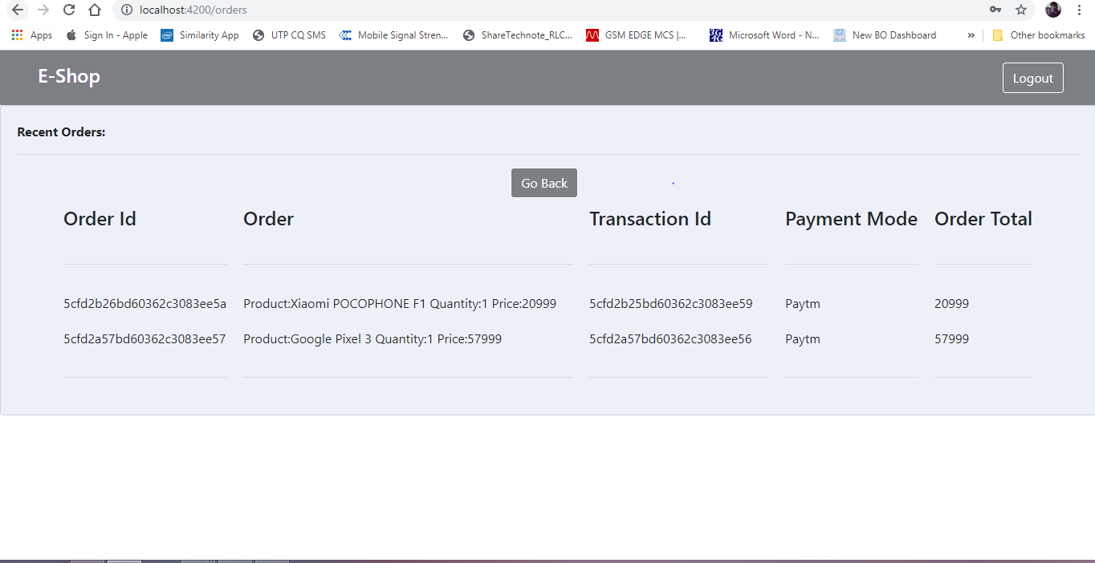

Different Payment Gateway Options integrated in the angular app:

1. Paytm
2. PayPal
3. Credit/Debit Card

**Server: Node Js**

**Database: Mongo DB**

**1. Paytm Payment Service:**

Paytm account details entered by user are sent to the server where the details of account and order price are stored on the database.

When the details are stored successfully, the server returns the result along with the transaction id,

Then the place order service is called to place the order and returns the final confirmation of order along with the order id.

**2. PayPal Payment Service:**

PayPal account details entered by user are sent to the server where the details of account and order price are stored on the database.

When the details are stored successfully, the server returns the result along with the transaction id,

Then the place order service is called to place the order and returns the final confirmation of order along with the order id.

**3. Credit/Debit Card Service:**

Credit/Debit Card details entered by user are sent to the server where the details and order price are stored on the database.

When the details are stored successfully, the server returns the result along with the transaction id,

Then the place order service is called to place the order and returns the final confirmation of order along with the order id.

**Paytm Payment Service:**

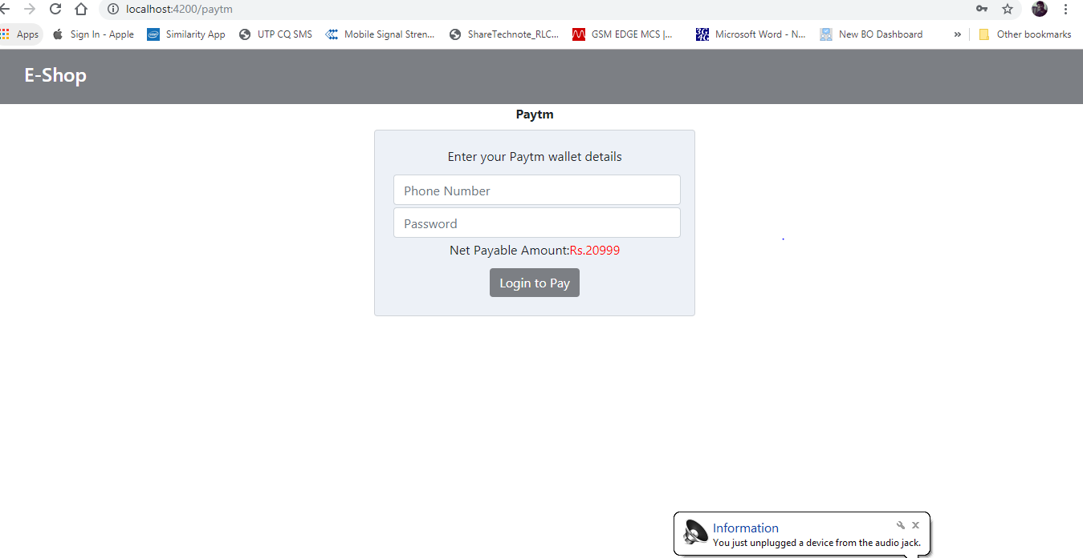

**PayPal Payments Service:**



**Credit/Debit Card:**

